

Programme Name: ________**BCS HONS**_______________________________________

Course Code: __**CSC 2515**________

Course Name: ________**Object Oriented Programming**______________________________

Assignment / **Lab Sheet** / Project / Case Study No. _**4**__

Date of Submission: ______**12/21/2020**_____________

**Submitted By: Submitted To:**

Student Name**: Dipesh Tha Shrestha** Faculty Name**: Som Prasad Shrestha**

IUKL ID: **041902900028** Department**: LMS**

Semester**: Third Semester**

Intake**: September 2019**

1. **Write a program that takes two integers as argument and returns their sum.**

**Ans:**

import java.util.Scanner;

public class Sum{

public static void main(String[] args) {

Scanner sc = new Scanner(System.in);

System.out.println("enter first number:");

int a=sc.nextInt();

System.out.println("enter second number:");

int b=sc.nextInt();

int sum = result(a, b);

sc.close();

System.out.println("the sum of two number is: " +sum);

}

static int result(int num1, int num2){

int result =num1+num2;

return result;

}

}

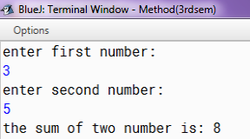

1. Write a Java method to find the smallest number among three numbers.

Ans:

import java.util.Scanner;

public class Smallest {

public static void main(String[] args){

Scanner sc= new Scanner(System.in);

System.out.println("enter first number: ");

int num1=sc.nextInt();

System.out.println("enter second number: ");

int num2=sc.nextInt();

System.out.println("enter third number: ");

int num3=sc.nextInt();

sc.close();

int min=minimum(num1, num2, num3);

System.out.println("the minimnum number among this is :" +min);

}

static int minimum(int a, int b, int c){

return Math.min(Math.min(a, b), c);

}

}

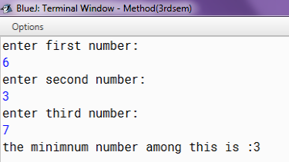

1. Write a Java method to compute the average of three numbers.

Ans:

import java.util.Scanner;

public class Average {

public static void main(String[] args){

Scanner sc= new Scanner(System.in);

System.out.println("enter first number: ");

int num1=sc.nextInt();

System.out.println("enter second number: ");

int num2=sc.nextInt();

System.out.println("enter third number: ");

int num3=sc.nextInt();

sc.close();

int avg=averagenum(num1, num2, num3);

System.out.println("the minimnum number among this is :" +avg);

}

static int averagenum(int a, int b, int c){

return (a+b+c)/3;

}

}

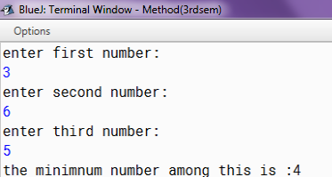

1. Write a Java method to display the middle character of a string.

Note: a) If the length of the string is even there will be two middle characters.

b) If the length of the string is odd there will be one middle character.

Ans:

import java.util.Scanner;

public class MidString {

public static void main(String[] args)

{

Scanner sc = new Scanner(System.in);

System.out.print("Input a string: ");

String st = sc .nextLine();

sc.close();

System.out.print("The middle character in the string: " + middle(st)+"\n");

}

public static String middle(String str)

{

int position;

int length;

if (str.length() % 2 == 0)

{

position = str.length() / 2 - 1;

length = 2;

}

else

{

position = str.length() / 2;

length = 1;

}

return str.substring(position, position + length);

}

}

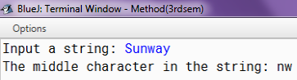

1. Write a Java method to count all vowels in a string.

Test Data:

Input the string: w3resource

Expected Output:

Number of Vowels in the string: 4

Ans:

import java.util.Scanner;

public class Count {

public static void main(String[] args)

{

Scanner sc= new Scanner(System.in);

System.out.print("Input the string: ");

String st = sc.nextLine();

sc.close();

System.out.print("Number of Vowels in the string: " + count_Vowels(st)+"\n");

}

public static int Vowels(String str)

{

int count = 0;

for (int i = 0; i < str.length(); i++)

{

if (str.charAt(i) == 'a' || str.charAt(i) == 'e' || str.charAt(i) == 'i'

|| str.charAt(i) == 'o' || str.charAt(i) == 'u')

{

count++;

}

}

return count;

}

}

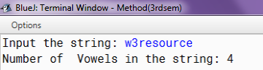

1. Write a Java method to count all words in a string.

Ans:

import java.util.Scanner;

public class Countwords {

public static void main(String[] args) {

Scanner sc = new Scanner(System.in);

System.out.println("Enter any string data: ");

String str = sc.nextLine();

System.out.println(countWords(str));

sc.close();

}

public static int count(String str) {

int count = 0;

for (int i = 0; i < str.length(); i++) {

char ch = str.charAt(i);

if (ch == ' ') {

count++;

}

}

return (count + 1);

}

}

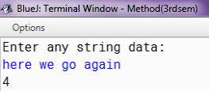

1. Write a Java method to compute the sum of the digits in an integer.

Ans:

import java.util.Scanner;

public class SumOfDig {

public static void main(String[] args)

{

Scanner sc = new Scanner(System.in);

System.out.print("Input an integer: ");

int num = sc.nextInt();

sc.close();

System.out.println("The sum is " + sumDigits(num));

}

public static int digits(long n) {

int result = 0;

while(n > 0) {

result += n % 10;

n /= 10;

}

return result;

}

}

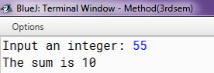

1. Write a Java method to compute the future investment value at a given interest rate for a specified number of years.

Ans:

import java.util.Scanner;

public class FutureInvest {

public static void main(String[] args) {

Scanner sc = new Scanner(System.in);

System.out.print("Input the investment amount: ");

double invest = sc.nextDouble();

System.out.print("Input the rate of interest: ");

double rate = sc.nextDouble();

System.out.print("Input number of years: ");

int year = sc.nextInt();

sc.close();

rate *= 0.01;

System.out.println("Years FutureValue");

for(int i = 1; i <= year; i++) {

int formatter = 19;

if (i >= 10) formatter = 18;

System.out.printf(i + "%"+formatter+".2f\n", futureInvestmentValue(invest, rate/12, i));

}

}

public static double futureInvestmentValue(double investmentAmount, double monthlyInterestRate, int years) {

return investmentAmount * Math.pow(1 + monthlyInterestRate, years * 12);

}}

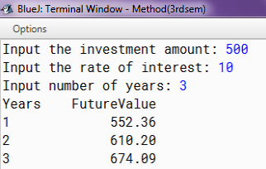

1. Write a Java method to print characters between two characters (i.e. A to P ).

Note: Prints 20 characters per line

Ans:

public class PrintChar {

public static void main(String[] args) {

print_Chars('(', 'z', 20);

}

public static void print_Chars(char char1, char char2, int n) {

for (int ctr = 1; char1 <= char2; ctr++, char1++) {

System.out.print(char1 + " ");

if (ctr % n == 0) System.out.println("");

}

System.out.print("\n");

}

}

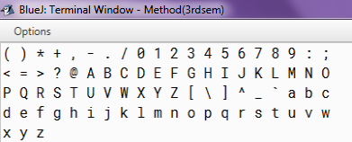

1. Write a Java method to check whether a year (integer) entered by the user is a leap year or not.

Ans:

import java.util.Scanner;

public class LeapYear {

public static void main(String[] args)

{

Scanner sc = new Scanner(System.in);

System.out.print("Input a year: ");

int year = sc.nextInt();

sc.close();

System.out.println(is_LeapYear(year));

}

public static boolean is_LeapYear(int y)

{

boolean a = (y % 4) == 0;

boolean b = (y % 100) != 0;

boolean c = ((y % 100 == 0) && (y % 400 == 0));

return a && (b || c);

}

}

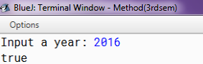

1. Write a Java method to check whether a string is a valid password.

Password rules:

A password must have at least ten characters.

A password consists of only letters and digits.

A password must contain at least two digits.

Expected Output:

Ans:

import java.util.Scanner;

public class Password {

public static final int PASSWORD_LENGTH = 10;

public static void main(String[] args) {

Scanner sc = new Scanner(System.in);

System.out.println("1. A password must have at least Ten characters");

System.out.println("2. A password consists of only letters and digits");

System.out.println("3. A password must contain at least two digits");

System.out.println("Input a password (You are agreeing to the above Terms and Conditions)");

String st = sc.nextLine();

sc.close();

if (is_Valid_Password(st)) {

System.out.println("Password is valid: " + st);

} else {

System.out.println("Not a valid password: " + st);

}

}

public static boolean is_Valid_Password(String password) {

if (password.length() < PASSWORD_LENGTH) return false;

int charCount = 0;

int numCount = 0;

for (int i = 0; i < password.length(); i++) {

char ch = password.charAt(i);

if (is_Numeric(ch)) numCount++;

else if (is_Letter(ch)) charCount++;

else return false;

}

return (charCount >= 2 && numCount >= 2);

}

public static boolean is_Letter(char ch) {

ch = Character.toUpperCase(ch);

return (ch >= 'A' && ch <= 'Z');

}

public static boolean is_Numeric(char ch) {

return (ch >= '0' && ch <= '9');

}

}   
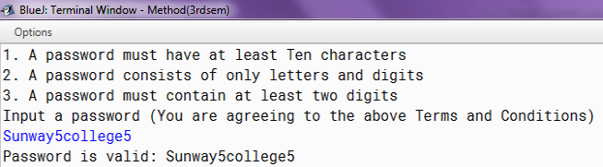

1. Write a Java method (takes a number n as input) to displays an n-by-n matrix. (0’s and 1’s displayed are random)

Ans:

import java.util.Scanner;

import java.util.Random;

public class Matrix{

public static void main(String[] args)

{

Scanner sc = new Scanner(System.in);

System.out.print("Input a number: ");

int n = sc.nextInt();

sc.close();

matrix(n);

}

public static void nMatrix(int n) {

Random r=new Random();

for(int i = 0; i < n; i++) {

for(int j = 0; j < n; j++) {

System.out.print(r.nextInt(2));

}

System.out.println();

}

}

}

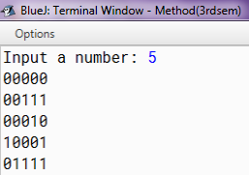

1. Write Java methods to calculate the area of a triangle.

Ans:

import java.util.Scanner;

public class AreaofTrian {

public static void main(String[] args)

{

Scanner sc = new Scanner(System.in);

System.out.print("Input first Side: ");

double side1 = sc.nextDouble();

System.out.print("Input second Side: ");

double side2 = sc.nextDouble();

System.out.print("Input third Side: ");

double side3 = sc.nextDouble();

sc.close();

System.out.println( is_Valid(side1, side2,side3) ?

"The area of the triangle is " + area_triangle(side1, side2, side3) : "Invalid triangle" );

}

public static boolean is_Valid(double side1, double side2, double side3) {

if( side1 + side2 > side3 &&

side2 + side3 > side1 &&

side1 + side3 > side2) return true;

else return false;

}

public static double area_triangle(double side1, double side2, double side3) {

double area = 0;

double s = (side1 + side2 + side3)/2;

area = Math.sqrt(s*(s - side1)*(s - side2)*(s - side3));

return area;

}}

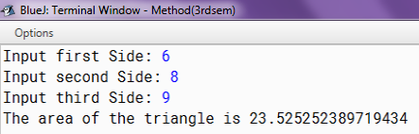

1. Write a Java method to find all twin prime numbers less than 100.

Ans:

public class TwinPrime {

public static void main(String[] args) {

for (int i = 2; i < 100; i++) {

if (is_Prime(i) && is_Prime(i + 2)) {

System.out.printf("%d, %d\n", i, i + 2);

}

}

}

public static boolean is_Prime(long n) {

if (n < 2) return false;

for (int i = 2; i <= n / 2; i++) {

if (n % i == 0)

return false;

}

return true;

}

}

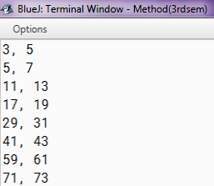

1. Write a method that takes an integer as argument and checks if the number is palindrome or not. The method should return true if the number is palindrome or false if not. Write a main method to check the method you have created.

Ans:

import java.util.Scanner;

public class Palindrome {

public static int reverseDigits(int num) {

int rev = 0;

while (num > 0) {

rev = rev * 10 + num % 10;

num = num / 10;

}

return rev;

}

static int isPalindrome(int n) {

int rev1 = reverseDigits(n);

if (rev1 == n)

return 1;

else

return 0;

}

public static void main(String[] args) {

Scanner sc = new Scanner(System.in);

System.out.println("Enter the numer");

int n = sc.nextInt();

System.out.println("Is: " + n + " a Palindrome number?: " + (isPalindrome(n) == 1 ? "\ttrue" : "\tfalse"));

sc.close();

}

}

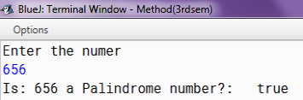

1. Write a method named operation that takes two integer arguments and a char argument, perform the calculation as per the char argument, and return the result:

Ans:

import java.util.Scanner;

public class Arguement {

public static void main(String[] args) {

Scanner sc = new Scanner(System.in);

System.out.println("Enter two number and an arthimetic operator:");

int num1 = sc.nextInt();

int num2 = sc.nextInt();

char ch = sc.next().charAt(0);

System.out.println(operateAsPerArgument(num1, num2, ch));

sc.close();

}

public static int operateAsPerArgument(int num1, int num2, char ch) {

int total = 0;

switch (ch) {

case '+':

total = num1 + num2;

break;

case '-':

total = num1 - num2;

break;

case '*':

total = num1 * num2;

break;

case '/':

total = num1 / num2;

break;

case '%':

total = num1 % num2;

break;

default:

System.out.println("Invalid Operator.");

break;

}

return total;

}

}

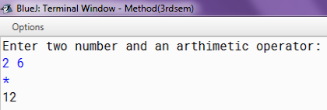

1. Write a program that uses the function *power()* to raise a number *m* to power *n*. The function takes integer values for *m* and *n* and returns the result correctly. Use a default value of 2 for *n* to make the function calculate squares when this argument is omitted. Write a function *main()* to pass the value of m and n and display the calculated result.

Ans:

import java.util.Scanner;

public class Power{

public static void main(String[] args) {

Scanner sc = new Scanner(System.in);

System.out.println("Enter value of m:");

int m = sc.nextInt();

System.out.println("Enter value of n:");

int n = sc.nextInt();

System.out.println("Calculated result: " + power(m, n));

sc.close();

}

static int power(int m, int n) {

int sum = 1;

for (int i = 1; i <= n; i++) {

sum *= m;

}

return sum;

}

static int power(int m) {

return (int) Math.pow(m, 2);

}

}

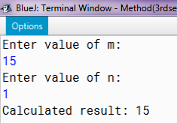

1. Write a method that reverses the string passed as argument.

Ans:

import java.util.Scanner;

public class Reverse {

String reverse(String s) {

if (s.length() == 0)

return " ";

return s.charAt(s.length() - 1) + reverse(s.substring(0, s.length() - 1));

}

public static void main(String[] arg) {

Reverse_18 rev = new Reverse_18();

Scanner sc = new Scanner(System.in);

System.out.print("Enter a string : ");

String str = sc.nextLine();

System.out.println("Reverse of a String :" + rev.reverse(str));

sc.close();

}

}

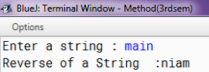

1. Write a method that replaces all the vowels of a string passed as argument with the next character.

Ans:

import java.util.Scanner;

public class ReplaceVow{

static boolean isVowel(char ch) {

if (ch != 'a' && ch != 'e' && ch != 'i' && ch != 'o' && ch != 'u') {

return false;

}

return true;

}

static String replaceConsonants(char[] st) {

for (int i = 0; i < st.length; i++) {

if (isVowel(st[i])) {

if (st[i] == 'z') {

st[i] = 'b';

}

else {

st[i] = (char) (st[i] + 1);

if (isVowel(st[i])) {

st[i] = (char) (st[i] + 1);

}

}

}

}

return String.valueOf(st);

}

public static void main(String[] args) {

Scanner sc = new Scanner(System.in);

System.out.print("Enter the String: ");

String Str = sc.next();

System.out.println(replaceConsonants(Str.toCharArray()));

sc.close();

}

}

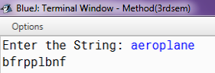

1. Write a method that accepts two strings as an argument, str1 and str2, and checks whether if str2 is substring of str1 or not.

Ans:

import java.util.Scanner;

public class Substring {

static boolean isSubstring(String str1, String str2, int m, int n) {

if (m == 0)

return true;

if (n == 0)

return false;

if (str1.charAt(m - 1) == str2.charAt(n - 1))

return isSubstring(str1, str2, m - 1, n - 1);

return isSubstring(str1, str2, m, n - 1);

}

public static void main(String[] args) {

Scanner sc = new Scanner(System.in);

System.out.println("Enter String 1");

String st1 = sc.nextLine();

System.out.println("Enter String 1");

String st2 = sc.nextLine();

int l1 = st1.length();

int l2 = st2.length();

boolean result = isSubstring(st1, st2, l1, l2);

if (result)

System.out.println("Yes");

else

System.out.println("No");

sc.close();

}

}

